WEEK 6

SESSION 1: KMP AlgorithM

TASK 1: String Similarity

Program :
import java.util.*;

public class Solution {

static long stringSimilarity(String s) {
int n = s.length();
int[] z = new int[n];

int left = 0;
int right = 0;

for (int i = 1; i < n; i++) {

if (i <= right) {
z[i] = Math.min(right - i + 1, z[i - left]);
}

while (i + z[i] < n &&
s.charAt(z[i]) == s.charAt(i + z[i])) {
z[i]++;
}

if (i + z[i] - 1 > right) {
left = i;
right = i + z[i] - 1;
}
}

long sum = n;

for (int i = 1; i < n; i++) {
sum += z[i];
}

return sum;
}

public static void main(String[] args) {
Scanner sc = new Scanner(System.in);

int t = sc.nextInt();

while (t-- > 0) {
String s = sc.next();
System.out.println(stringSimilarity(s));
}

sc.close();
}
}

Output :
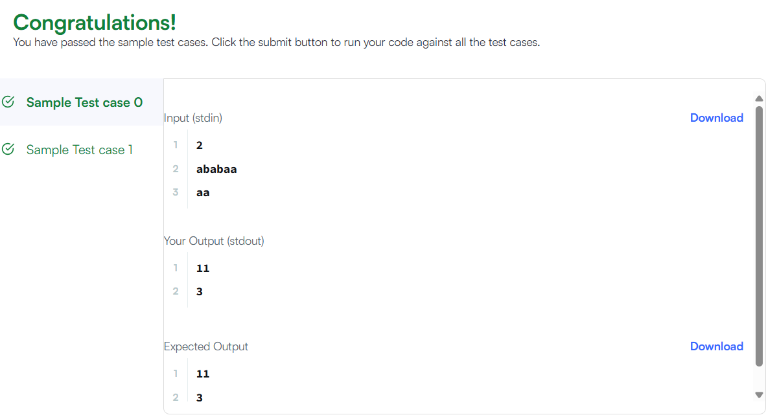

TASK 2: Repeated Substring pattern

Program :
class Solution {
public boolean repeatedSubstringPattern(String s) {
String doubled = s + s;

return doubled.substring(1, doubled.length() - 1).contains(s);
}
}

Output:
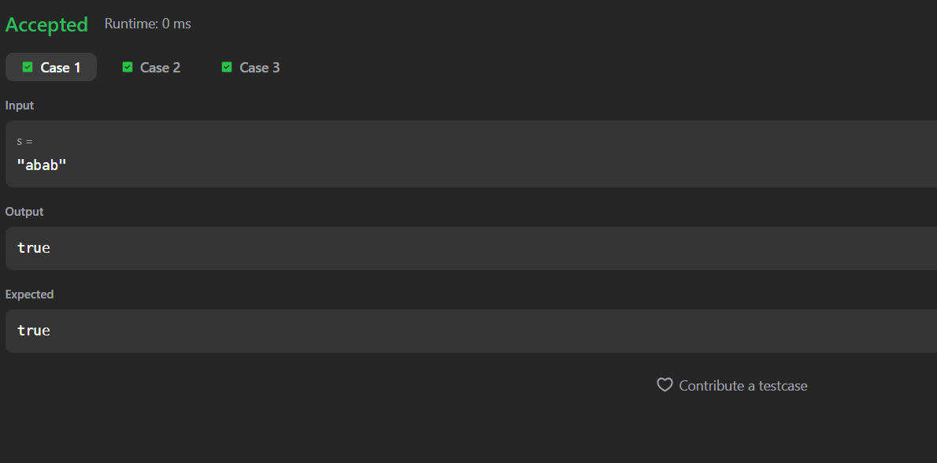

SESSION 2: KMP Applications

TASK 3 : Two Strings

Program:
import java.util.*;

public class Solution {

public static String twoStrings(String s1, String s2) {
boolean[] present = new boolean[26];

for (char c : s1.toCharArray()) {
present[c - 'a'] = true;
}

for (char c : s2.toCharArray()) {
if (present[c - 'a']) {
return "YES";
}
}

return "NO";
}

public static void main(String[] args) {
Scanner sc = new Scanner(System.in);

int t = sc.nextInt();

while (t-- > 0) {
String s1 = sc.next();
String s2 = sc.next();

System.out.println(twoStrings(s1, s2));
}

sc.close();
}
}

Output:
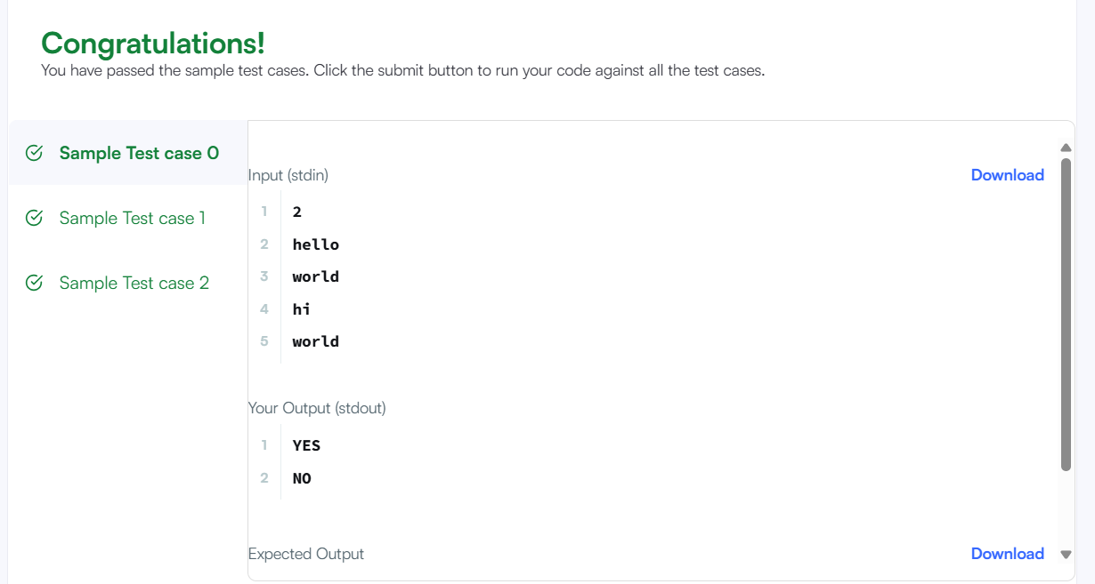

TASK 4: Rotate String

Program :
class Solution {
public boolean rotateString(String s, String goal) {

if (s.length() != goal.length()) {
return false;
}

String doubled = s + s;

return doubled.contains(goal);
}
}

Output :
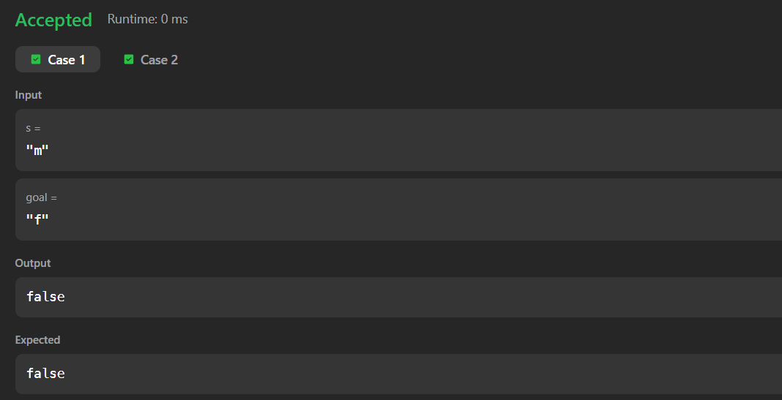

SESSION 3 : Boyer Moore Algorithm

TASK 5 : Mars Exploration

Program :
import java.util.*;

public class Solution {

public static int marsExploration(String s) {
int count = 0;

String pattern = "SOS";

for (int i = 0; i < s.length(); i++) {
if (s.charAt(i) != pattern.charAt(i % 3)) {
count++;
}
}

return count;
}

public static void main(String[] args) {
Scanner sc = new Scanner(System.in);

String s = sc.next();

System.out.println(marsExploration(s));

sc.close();
}
}

Output:
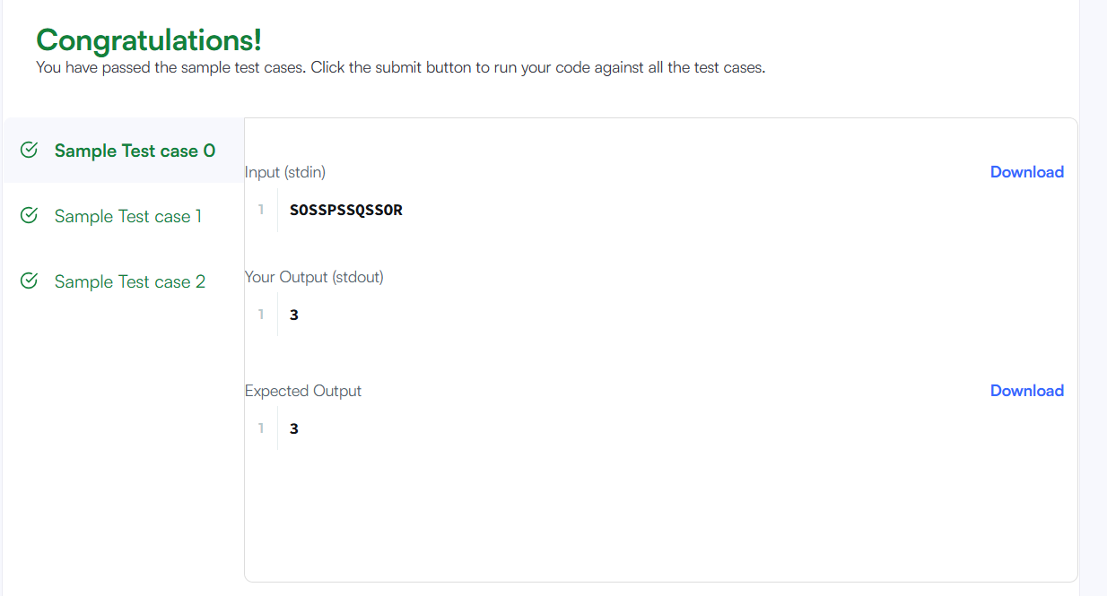

TASK 6: Find all anagrams in a string

Program :
import java.util.*;

class Solution {
public List<Integer> findAnagrams(String s, String p) {
List<Integer> result = new ArrayList<>();

if (s.length() < p.length()) {
return result;
}

int[] pCount = new int[26];
int[] windowCount = new int[26];

for (char c : p.toCharArray()) {
pCount[c - 'a']++;
}

int windowSize = p.length();

for (int i = 0; i < s.length(); i++) {
windowCount[s.charAt(i) - 'a']++;

if (i >= windowSize) {
windowCount[s.charAt(i - windowSize) - 'a']--;
}

if (Arrays.equals(pCount, windowCount)) {
result.add(i - windowSize + 1);
}
}

return result;
}
}

Output:
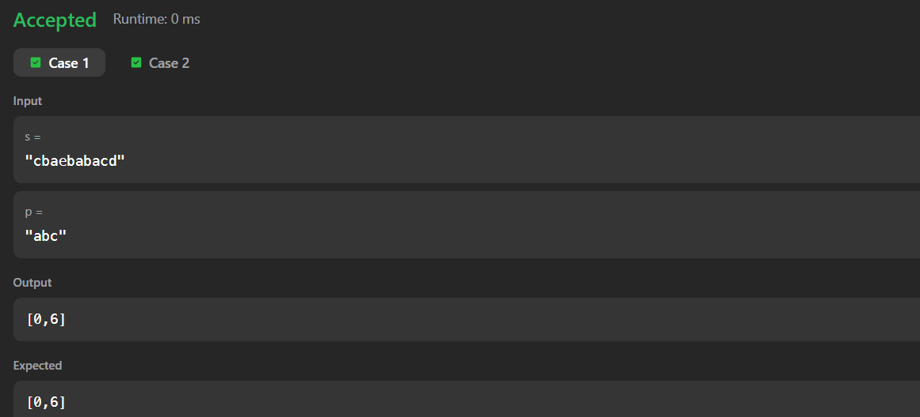

SESSION 4: Palindrome Techniques

TASK 7: Diagonal Difference

Program :
import java.io.*;
import java.util.*;

class Result {

public static int diagonalDifference(List<List<Integer>> arr) {
int n = arr.size();

int leftDiagonal = 0;
int rightDiagonal = 0;

for (int i = 0; i < n; i++) {
leftDiagonal += arr.get(i).get(i);
rightDiagonal += arr.get(i).get(n - 1 - i);
}

return Math.abs(leftDiagonal - rightDiagonal);
}
}

public class Solution {

public static void main(String[] args) throws IOException {
BufferedReader bufferedReader =
new BufferedReader(new InputStreamReader(System.in));

int n = Integer.parseInt(bufferedReader.readLine().trim());

List<List<Integer>> arr = new ArrayList<>();

for (int i = 0; i < n; i++) {
String[] values = bufferedReader.readLine().trim().split(" ");

List<Integer> row = new ArrayList<>();

for (int j = 0; j < n; j++) {
row.add(Integer.parseInt(values[j]));
}

arr.add(row);
}

int result = Result.diagonalDifference(arr);

System.out.println(result);

bufferedReader.close();
}
}

Output:
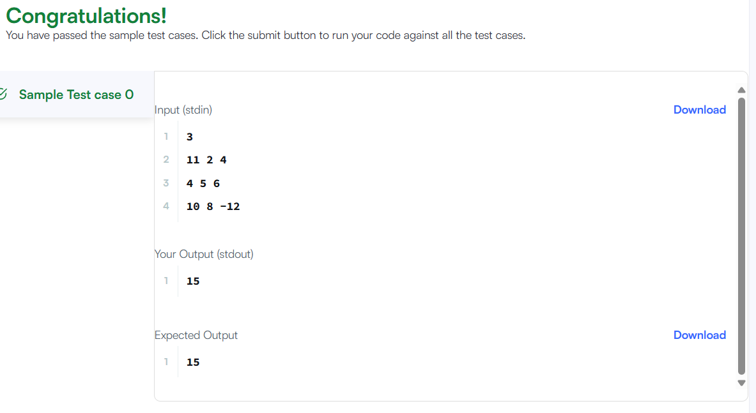

TASK 8: Transpose Matrix

Program :
class Solution {
public int[][] transpose(int[][] matrix) {

int m = matrix.length;
int n = matrix[0].length;

int[][] result = new int[n][m];

for (int i = 0; i < m; i++) {
for (int j = 0; j < n; j++) {
result[j][i] = matrix[i][j];
}
}

return result;
}
}

Output:
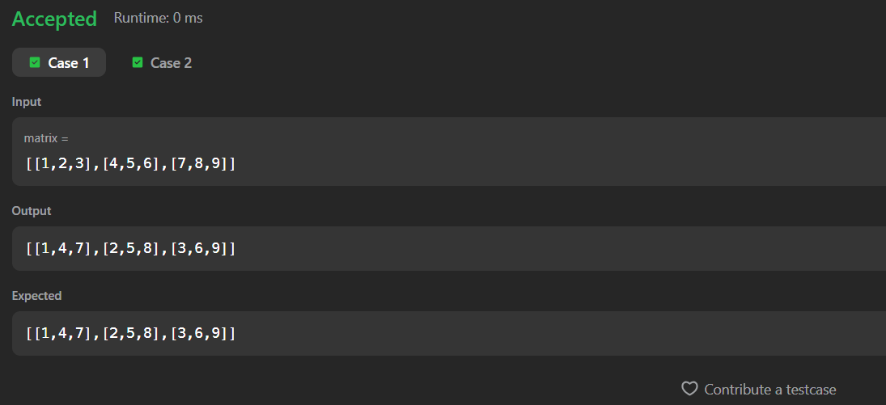

SESSION 5: Strassen’s Matrix Multiplication

TASK 9 : Matrix Block Sum

Program :
class Solution {
public int[][] matrixBlockSum(int[][] mat, int k) {

int m = mat.length;
int n = mat[0].length;

int[][] answer = new int[m][n];

for (int i = 0; i < m; i++) {
for (int j = 0; j < n; j++) {

int sum = 0;

int startRow = Math.max(0, i - k);
int endRow = Math.min(m - 1, i + k);

int startCol = Math.max(0, j - k);
int endCol = Math.min(n - 1, j + k);

for (int r = startRow; r <= endRow; r++) {
for (int c = startCol; c <= endCol; c++) {
sum += mat[r][c];
}
}

answer[i][j] = sum;
}
}

return answer;
}
}

Output:
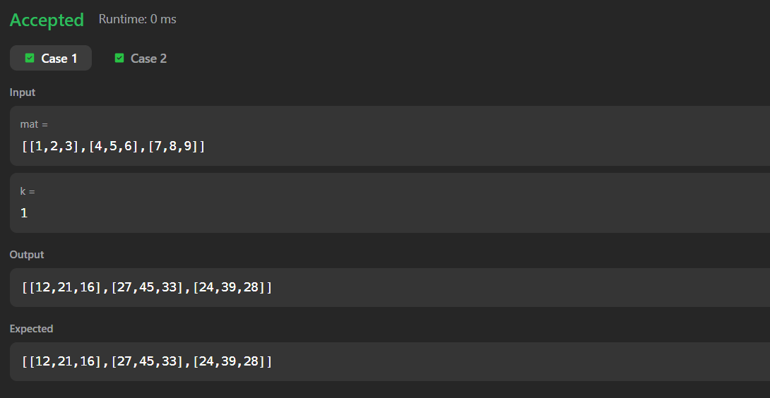

TASK 10: Matrix Layer Rotation

Program:
import java.io.*;
import java.util.*;

public class Solution {

public static void matrixRotation(List<List<Integer>> matrix, int r) {

int m = matrix.size();
int n = matrix.get(0).size();

int[][] arr = new int[m][n];

// Convert List to 2D array
for (int i = 0; i < m; i++) {
for (int j = 0; j < n; j++) {
arr[i][j] = matrix.get(i).get(j);
}
}

// Number of layers
int layers = Math.min(m, n) / 2;

for (int layer = 0; layer < layers; layer++) {

int top = layer;
int left = layer;
int bottom = m - 1 - layer;
int right = n - 1 - layer;

List<Integer> elements = new ArrayList<>();

// Top row: left -> right
for (int j = left; j <= right; j++) {
elements.add(arr[top][j]);
}

// Right column: top+1 -> bottom
for (int i = top + 1; i <= bottom; i++) {
elements.add(arr[i][right]);
}

// Bottom row: right-1 -> left
for (int j = right - 1; j >= left; j--) {
elements.add(arr[bottom][j]);
}

// Left column: bottom-1 -> top+1
for (int i = bottom - 1; i > top; i--) {
elements.add(arr[i][left]);
}

int size = elements.size();

// Anti-clockwise rotation
int shift = r % size;

int index = shift;

// Top row
for (int j = left; j <= right; j++) {
arr[top][j] = elements.get(index);
index = (index + 1) % size;
}

// Right column
for (int i = top + 1; i <= bottom; i++) {
arr[i][right] = elements.get(index);
index = (index + 1) % size;
}

// Bottom row
for (int j = right - 1; j >= left; j--) {
arr[bottom][j] = elements.get(index);
index = (index + 1) % size;
}

// Left column
for (int i = bottom - 1; i > top; i--) {
arr[i][left] = elements.get(index);
index = (index + 1) % size;
}
}

// Print result
for (int i = 0; i < m; i++) {
for (int j = 0; j < n; j++) {
System.out.print(arr[i][j]);

if (j < n - 1) {
System.out.print(" ");
}
}
System.out.println();
}
}

public static void main(String[] args) throws IOException {

BufferedReader br =
new BufferedReader(new InputStreamReader(System.in));

StringTokenizer st =
new StringTokenizer(br.readLine());

int m = Integer.parseInt(st.nextToken());
int n = Integer.parseInt(st.nextToken());
int r = Integer.parseInt(st.nextToken());

List<List<Integer>> matrix = new ArrayList<>();

for (int i = 0; i < m; i++) {

st = new StringTokenizer(br.readLine());

List<Integer> row = new ArrayList<>();

for (int j = 0; j < n; j++) {
row.add(Integer.parseInt(st.nextToken()));
}

matrix.add(row);
}

matrixRotation(matrix, r);
}
}

Output:
